EASTERN INTERNATIONAL UNIVERSITY Practice Assignment – Quarter 1, 2025- 2026
SCHOOL OF COMPUTING Course Name: Special Topic 1
AND INFORMATION TECHNOLOGY Course Code: CSE 484
aa Student’s Full Name: Hà Quang Minh
Lab 4
Student ID: 1931220012

Background Required Resources:
- Postman desktop app (latest version)
- Internet connection
- Or use DEVASC and CSR1000V

Questions:

Step 1: Get Public IP Address (Network Information)
- Open Postman → New → RequestName: Lab - Get IP → Save to a new Collection named HTTPBIN LAB
- Enter URL: GET https://httpbin.org/ip
- Click Send
- Response Body: (file json)
{
"origin": "180.148.6.78"
}
  - This is your public IP as seen by the server
- View detailed network info:
Next to the status code (200 OK), click the globe icon or info icon
You’ll see:
- Remote IP & Port
- TLS Version (e.g., TLSv1.3)
- Cipher suite

- DNS lookup, TCP handshake, TLS handshake, Time to First Byte, etc.

Step 2: Get All Request Headers

- Create a new request in the same Collection Name: Lab - Get Headers
- Enter URL:
GET https://httpbin.org/headers
- Click Send
- Response Body
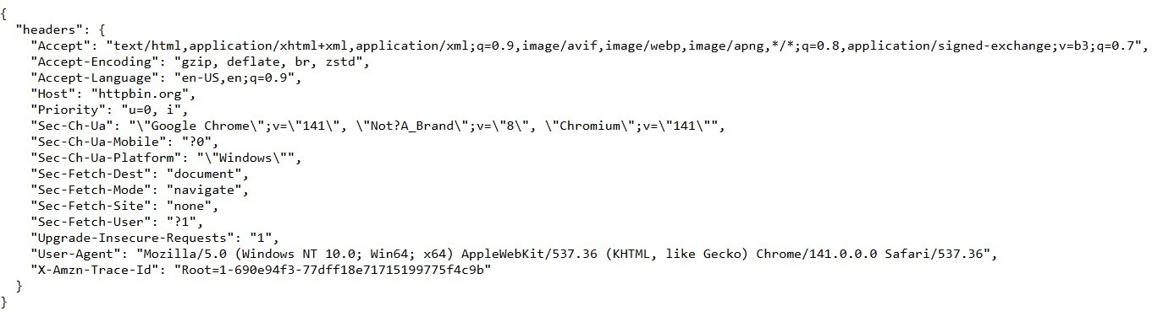

  - These are all headers automatically sent by Postman/your browser.

Step 3: View Detailed Network Logs in Postman Console

- Open Postman Console:View → Show Postman Console (or shortcut Ctrl+Alt+C / Cmd+Option+C)
- Resend both requests above
- In the Console, you’ll see:
  - Connected IP
  - Timing breakdown (DNS → TCP → TLS → First Byte)
  - Full request/response headers
  - Certificate chain (for HTTPS)

Step 4: Add Custom Headers (Advanced Practice)

- Go to the Headers tab of the https://httpbin.org/headers request
- Add these custom headers:
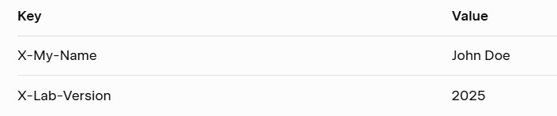

- Click Send again → Check response: (json file)

“X-My-Name”: “John Doe”,
“X-Lab-Version”: “2025”

Expected Outcomes
  - Retrieve public IP using Postman

Capture complete request/response headers
  - View detailed network metadata (TLS, cipher, timing)
  - Add and verify custom headers
  - Master Postman Console as a powerful debugging tool

My Solution:

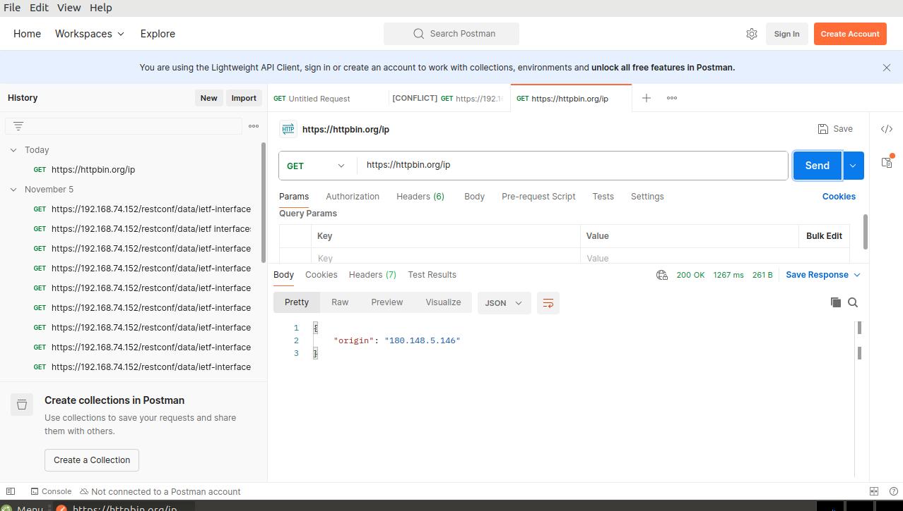
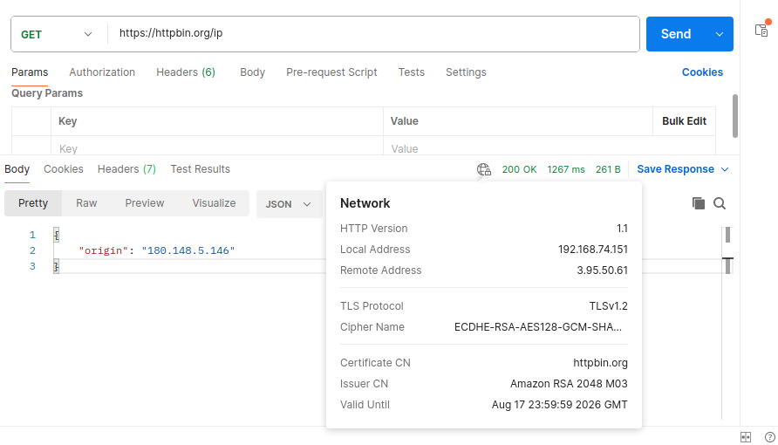
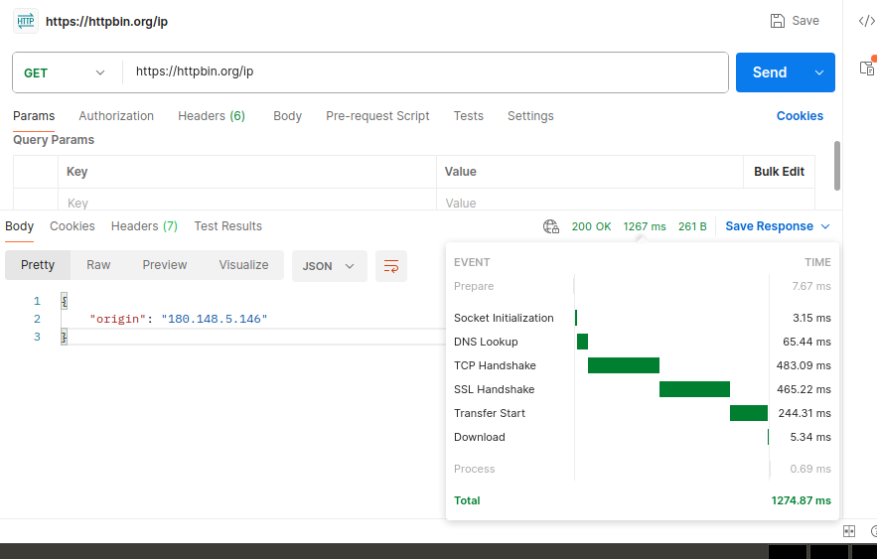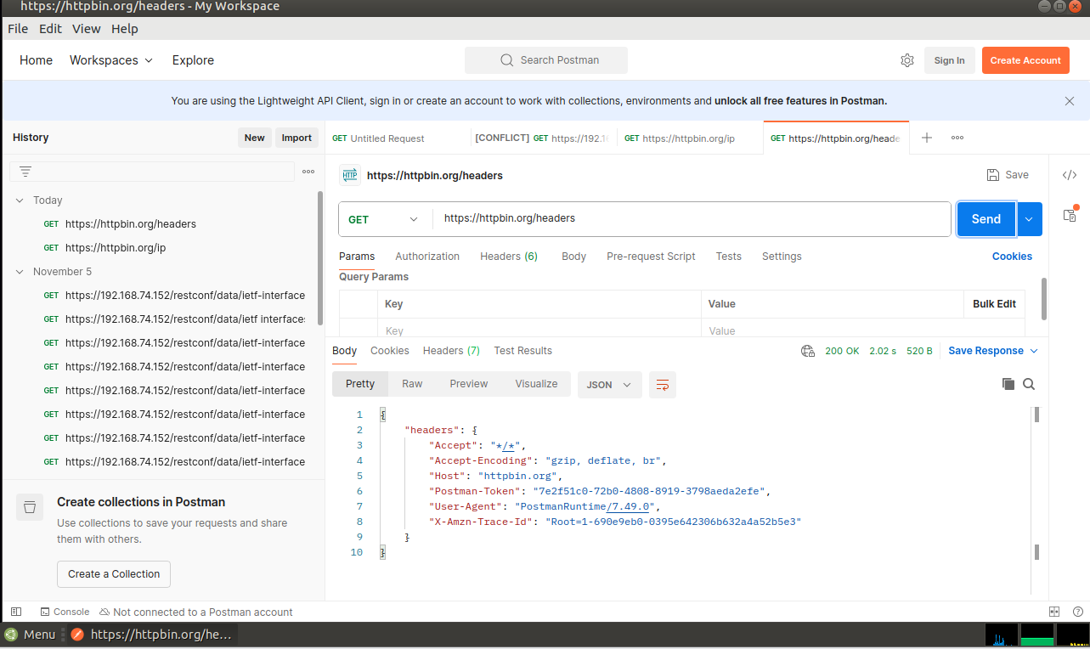
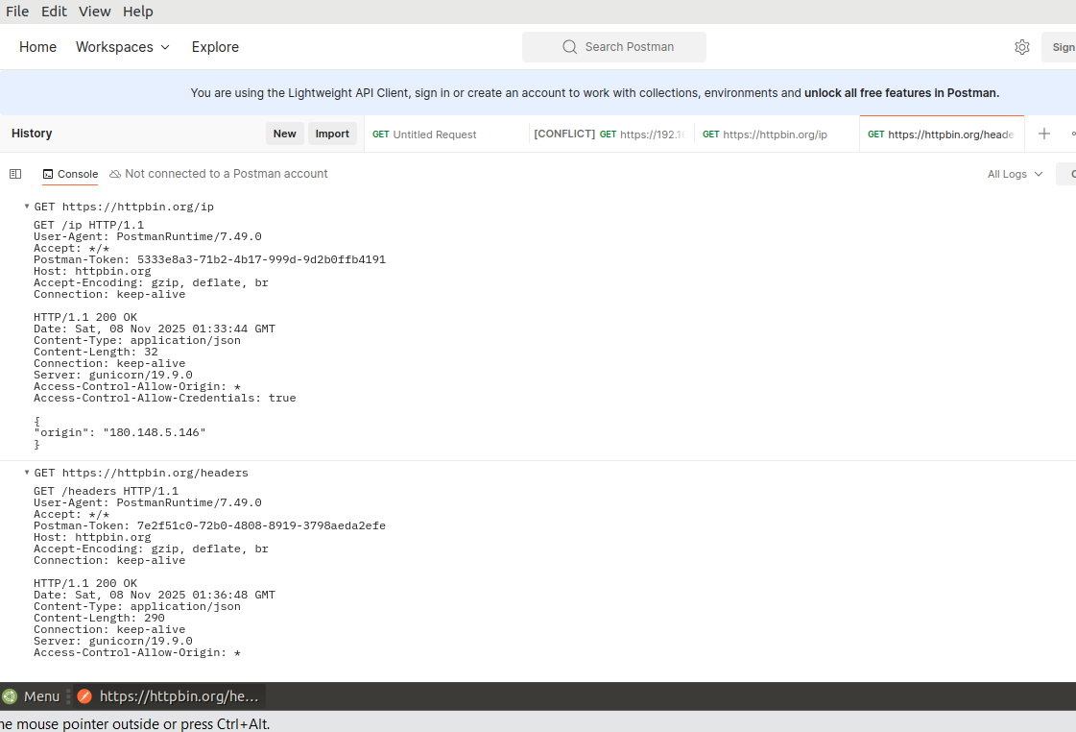

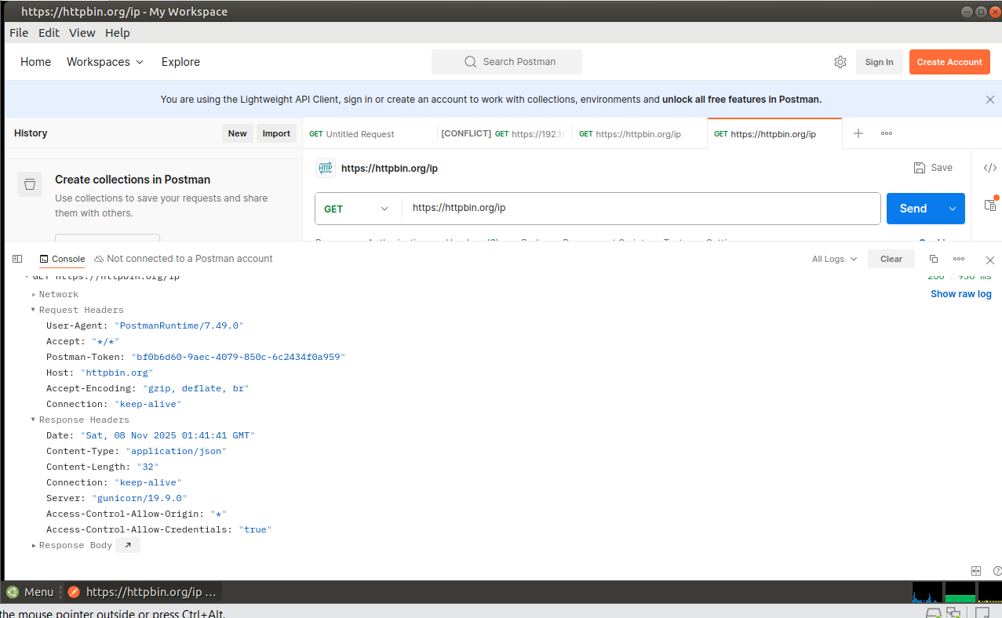
Step 4

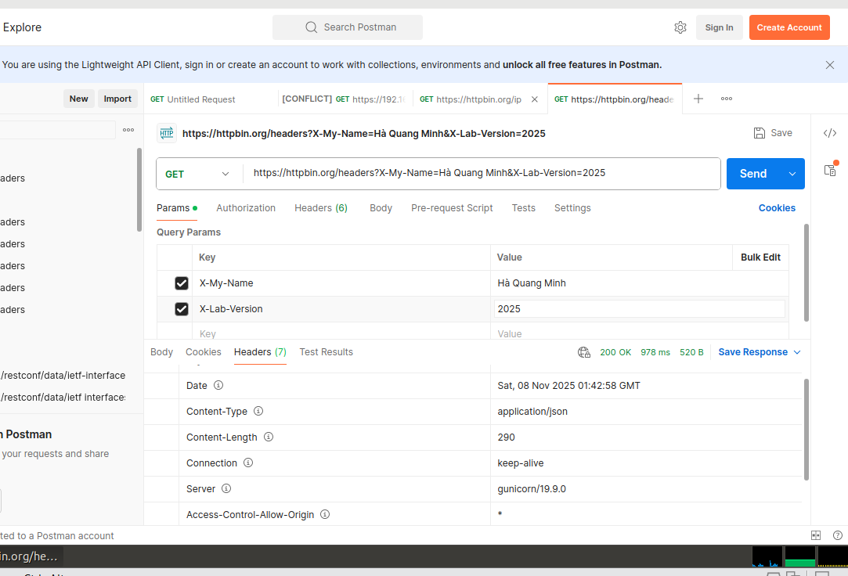
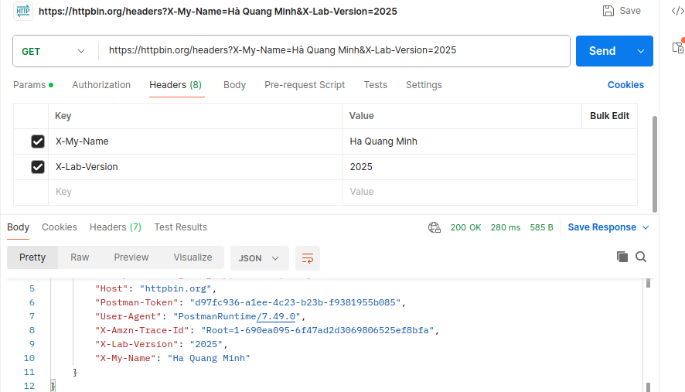

Expected Outcomes:

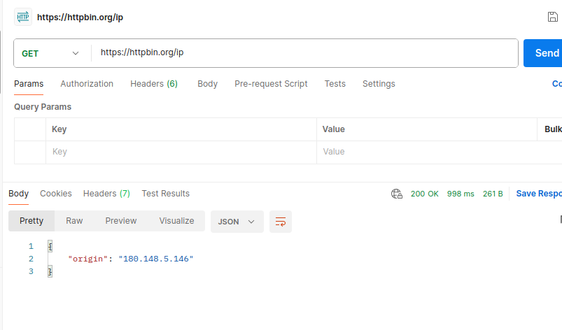
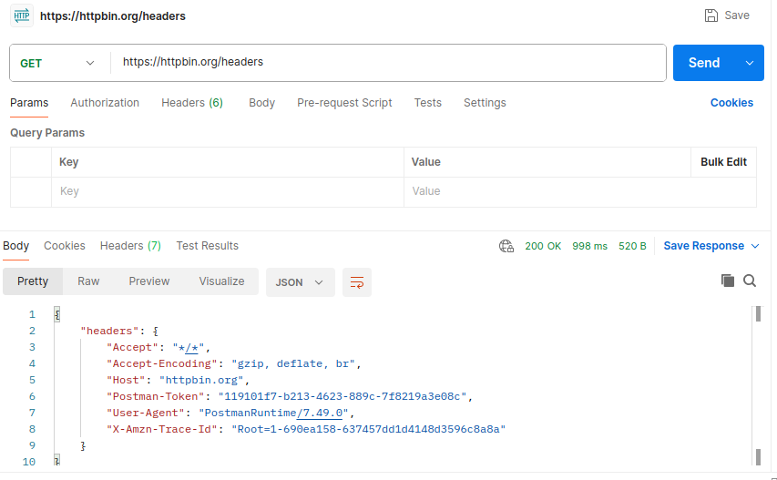

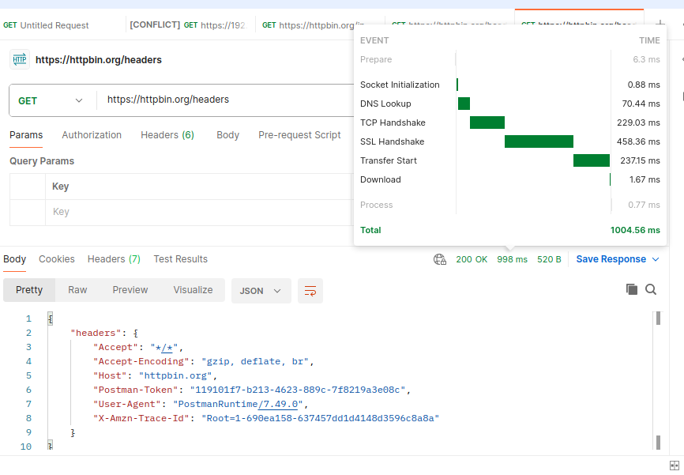
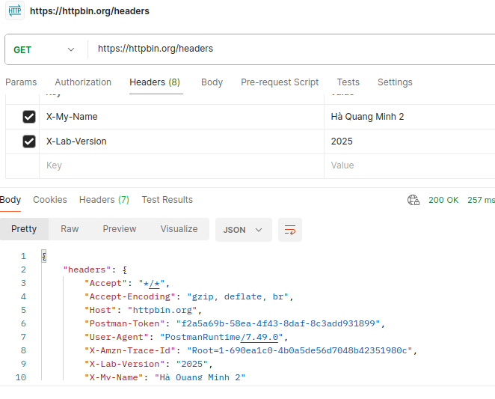

Part 2: Further Exploration
Try these additional httpbin.org endpoints:
  - https://httpbin.org/user-agent → returns only User-Agent
  - https://httpbin.org/get?name=abc&age=25 → view query parameters
  - https://httpbin.org/status/404 → test error codes
  - https://httpbin.org/anything → echoes everything (headers, body, method, etc.)

My Solution:

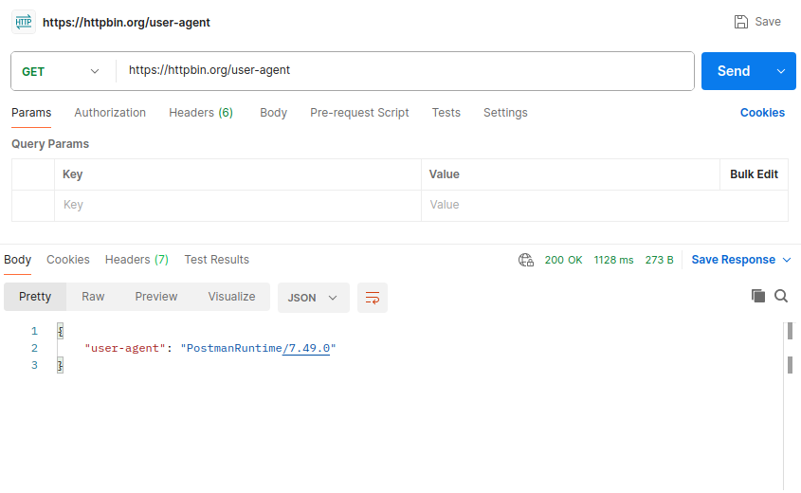
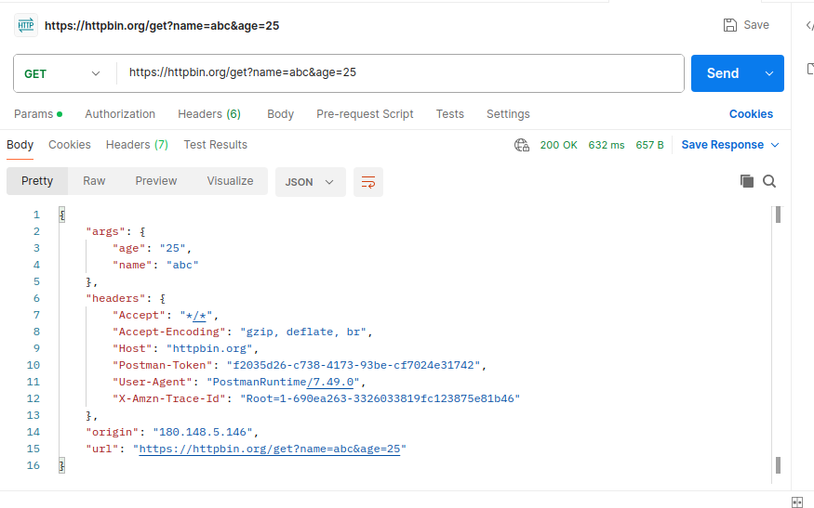
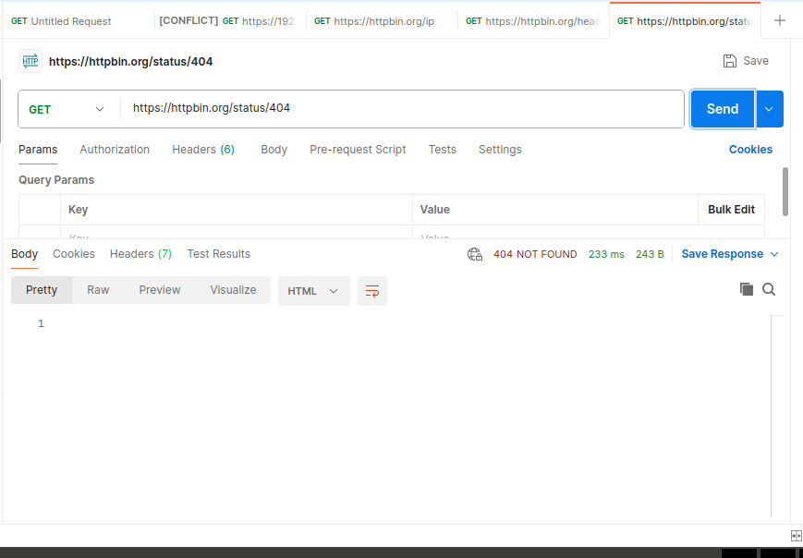
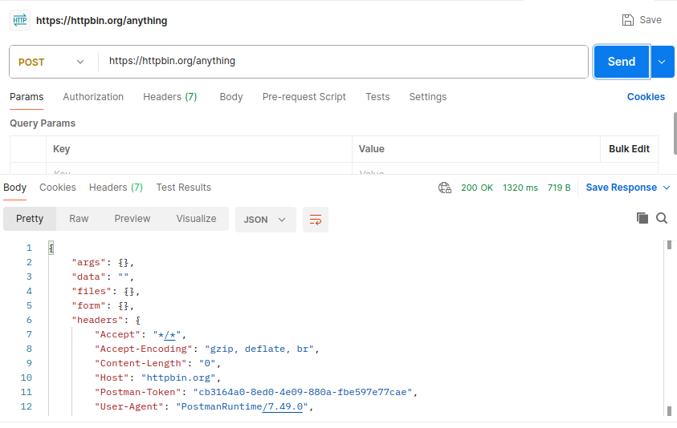
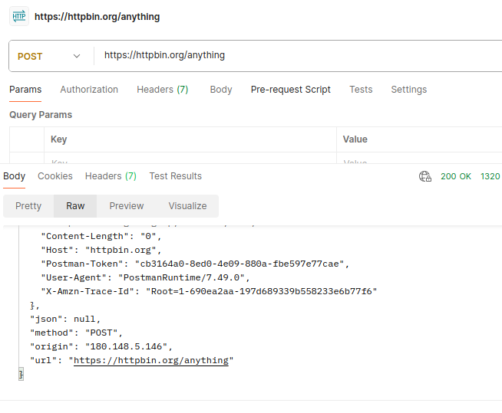
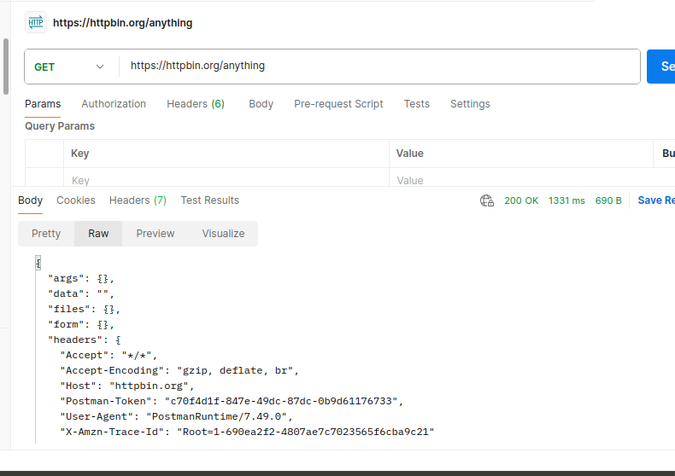

Submission: Must include:
- a pdf report file containing your information (student id, name), and images of the diagrams, codes, answers, evident,…
- and all source code files (if any)
in a zipped (.zip or *.rar) file to Moodle

